1. String 1 ;WITH cteBase common table expression is used.

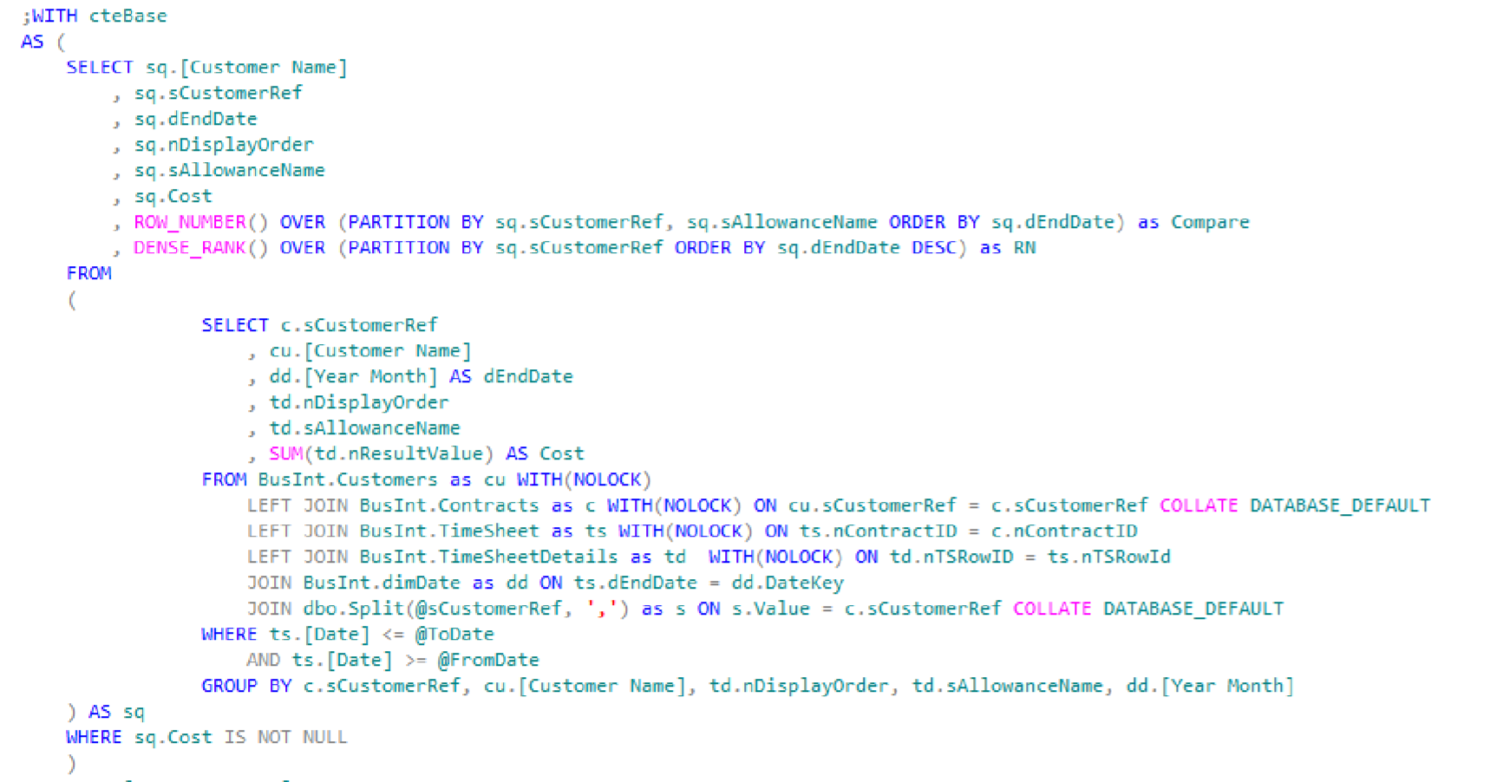

2. [Customer Name] use custom attribute name with spaces in name.



3.On the 9th line there is a function called ROW_NUMBER() this function will give a numeric

value to each row of the result set. These numbers will start at 1 for each combination

of sCustomerRef and sAllowanceName ordered by dEndDate.



4. On the 10 line there is a function called DENSE_RANK()

This function returns the rank of each row within a result set partition (sCustomerRef),

with no gaps in the ranking values. Values inside partition are ordered by dEndDate.

The rank of a specific row is one plus the number of distinct rank values that come before that specific row.



5. Line 12. Subquery is used. This subquery is used as <sq> temporary data source inside cteBase

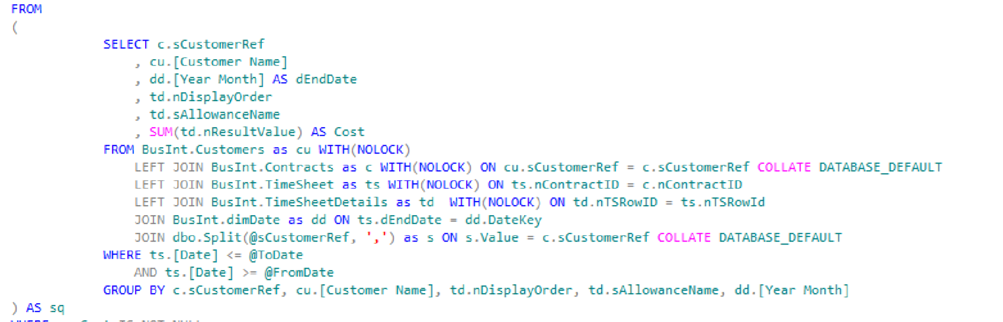

6. Line 18 **SUM Aggregation** for each combination of CustomerRef, [Customer Name], nDisplayOrder, sAllowanceName, [Year Month]

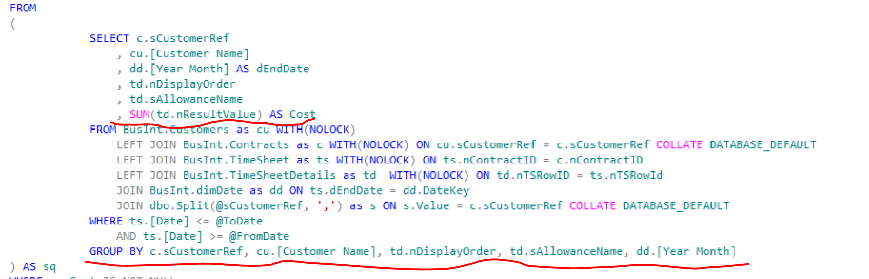

7. Line 19 WITH(NOLOCK) hint for duty read (READ UNCOMMITTED) from table BusInt.Customer



8. Line 19 BusInt.Customer Read data from Customer table in BusInt schema



9. Line 20 LEFT JOIN .... ON .... COLLATE Define collation that will affect result of string comparison result.

COLLATE is a clause applied to character string expression or column for textual data types to cast the string or column

collation into a specified collation.

COLLATE DATABASE_DEFAULT clause which will cast the character string expression or

column collation into the collation of the database context where the command is executed.



10. Join dbo.Split **user defined function** is used for splitting string into table value . Comma is used as a delimiter.



11. WHERE sq.Cost IS NOT NULL only rows with not null SUM(td.nResultValue) will be returned from sq subquery



12. LEFT(a.dEndDate, 4) AS [Year To Date] . dEndDate is a string that contains date information. LEFT function will return 4 fisrt charachters with year information

Alias [Year To Date] is used for function result.



13. CONVERT (MONEY, a.Cost) Cast a.Cost to MONEY data type



14. CASE WHEN Evaluates a list of conditions and returns one of multiple possible result expressions.



15. ORDER BY keyword is used to sort the result-set



16. OPTION recompile Query hint

Instructs the SQL Server Database Engine to generate a new, temporary plan for the query and immediately discard that plan after the query completes execution